Mililani Rosare

Cady

ISTE 252.01

12 December 2021

Project 3: Design Document

Development Process:

For this project, I broke it down into a few weeks. The breakdown is in the Discussion board post in myCourses.

The first step was coming up with an idea, which was more difficult than I thought. At the time, I was not sure what I wanted to design. One day, my teammate mentioned Animal Crossing. From there, I thought it would be an interesting app to make with the given API. This game has been with me since my childhood.

After coming up with an idea, I came up with a few designs with sketches. With the API I am using, they had many endpoints. However, I decided to stick to 3 different ones: villagers, fish, and bugs. These are some of the few most important parts of the game and what people would like to know as a reference. For my app, I wanted to have the following: bottom navigation, splash, list information, details, and error page.

From there, I began working in Figma. One thing that is a bit different from my sketches and Figma file is the details page containing the bottom navigation bar. Also, the Villagers page has their representative color listed in the API.

Finally, I moved on to the development process. I struggled at first due to the API endpoint. Luckily, the professor and I solved the problem to continue working. At first, I was only going to load in the fish data and its details when clicked on. However, I was able to add bottom navigation, which allowed me to display villagers and bugs. The final design contains most of the pages and styles initially planned. There is also an errors page, similar to the Figma file.

The pages and design that were not part of the final application were the splash page and bottom navigation throughout all the pages. Overall, due to time constraints and having errors while implementing them into the application. Lastly, one thing I did mention is user testing. I did not user test; however, I did show my designs to individuals throughout my development process.

Artifacts/Links:

*Sketches:*

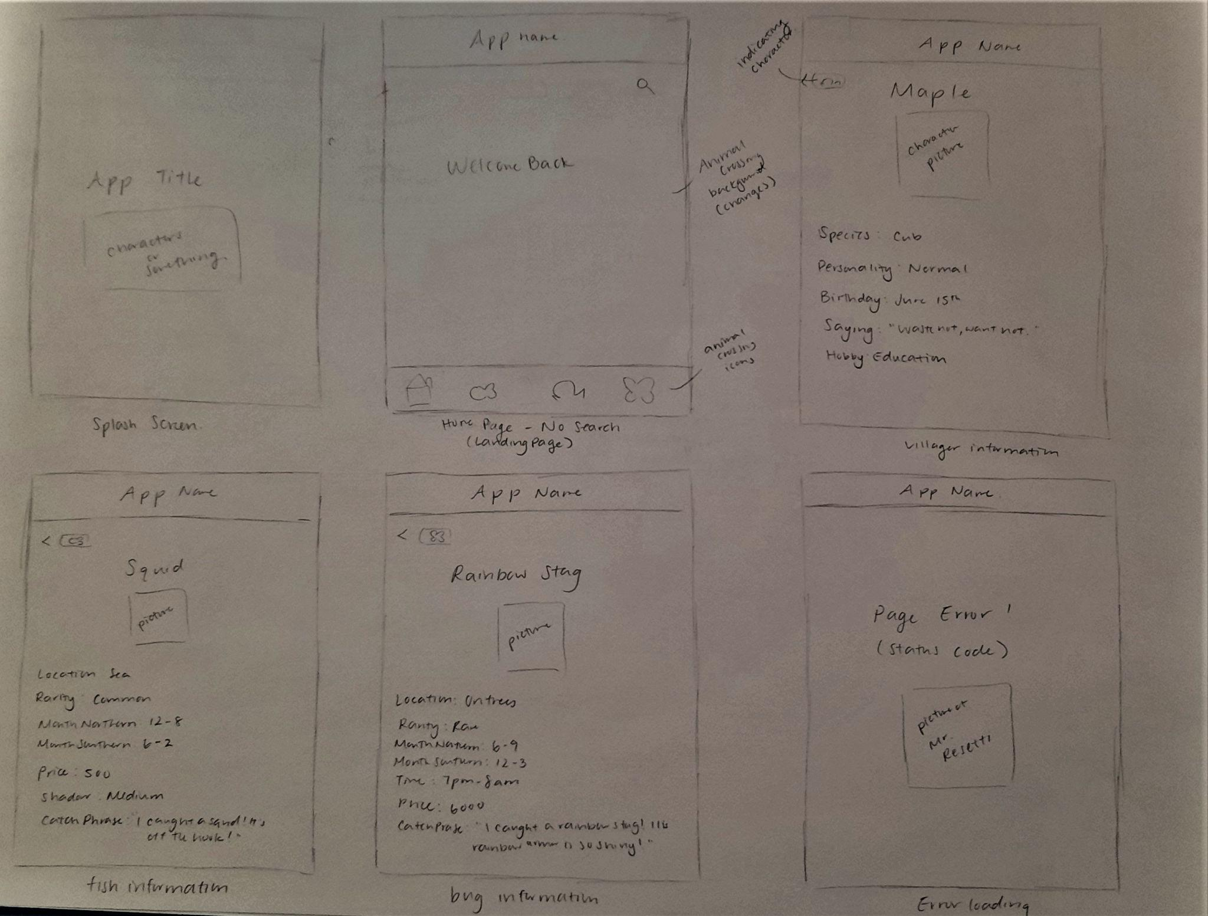

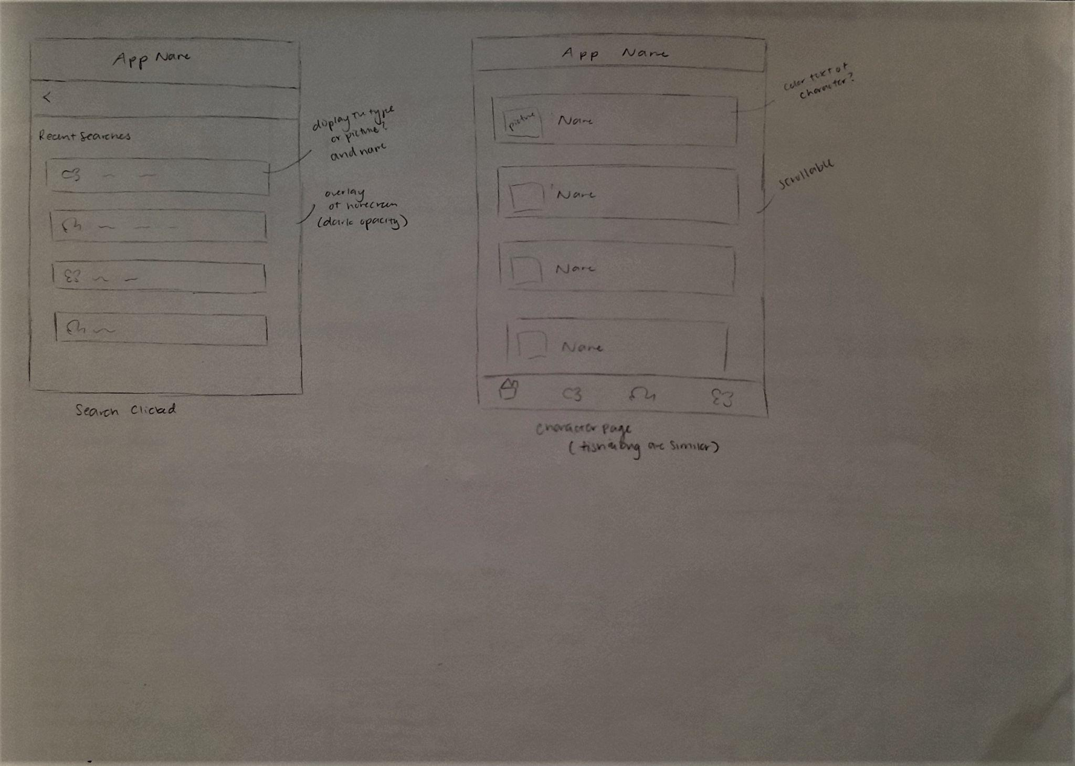

*Figma Design:* <https://www.figma.com/file/RI05vBuPr6M6H68ruDPnyO/Project-3%3A-Animal-Crossing?node-id=11%3A69>

*Figma Prototype:* <https://www.figma.com/proto/RI05vBuPr6M6H68ruDPnyO/Project-3%3A-Animal-Crossing?node-id=11%3A94&scaling=scale-down&page-id=0%3A1&starting-point-node-id=11%3A94>

*API Animal Crossing Description:* <http://acnhapi.com/>

*API Animal Crossing Documentation:* <http://acnhapi.com/doc>

*Material Design Icon:* <https://www.figma.com/community/file/878585965681562011>

Features:

A user can navigate through the application that contains three different endpoints from the Animal Crossing API. They have a selection of Villagers, Fish, and Bugs. For all three endpoints, there are pieces of data that display upon click. To navigate to different data points, the bottom navigation is available with an icon and name. If an error were to occur, an error message displays, and a picture of the Animal Crossing character: Resetti.

Success:

My original plan was to include three different data endpoints: villagers, fish, and bugs. They all successfully are listed when clicked on through the bottom navigation. If a user clicks on one of the options, they will be presented with information about the villager, fish, or bug, with an image displayed above.

Issues:

There are no known issues with the current application of loading data. However, there are a few designs that could be better. Additionally, a splash screen and a constant bottom navigation bar, that is not currently implemented.

There is an error displayed in the terminal, if a user scrolls too fast. (Error: *The provided ScrollController is currently attached to more than one ScrollPosition.*) However, this does not affect the data being displayed.

All code is currently in main.dart. For better implementation, these ideally would be in separate dart files.

Future Development:

There were a few things I was unable to complete for my final app. One thing I would have liked to add is a splash page. When implementing, I ran into a few problems loading the page and displaying information upon click.

There is also a bit of styling that could be better. For example, when it lists the data from the API, there is no spacing. It would have looked a bit cleaner with margins in between.

As I mentioned in the development process, the last thing I would have liked to add is bottom navigation that is constant throughout all the pages. It did follow my sketches, which I did not add bottom navigation. However, for a better user experience, it would be nice to have constant bottom navigation.

Lastly, it would be nice to load in all the data possible. The Animal Crossing API documentation has many other endpoints that I could use. If I were to implement this, I would remove the bottom navigation and create a hamburger widget. It would be the best way to display the data and create a better user experience. Also, a search page would be nice, to make it easier and quicker for searching purposes.